SMART ATTENDANCE MANAGEMENT SYSTEM

ABSTRACT:

Smart attendance system is the system of tacking the attendance of the student on basis of presence/Absent in class. Successful schools and universities begin by engaging students and making sure that they will come regularly so the attendance rate become very important. In this paper, a smart student attendance system is designed and implemented based on android application system(Android Studio). In [condensing](https://www.merriam-webster.com/thesaurus/condensing) with other conventional attendance systems, the proposed system provides faster, cheaper and accessible system for online student attendance and generate the attendance report automatically.

PROTOTYPE:

As we enter into our app .we will get an Activity/Screen in that we have a button called "**CLICK HERE TO CONTINUE"**

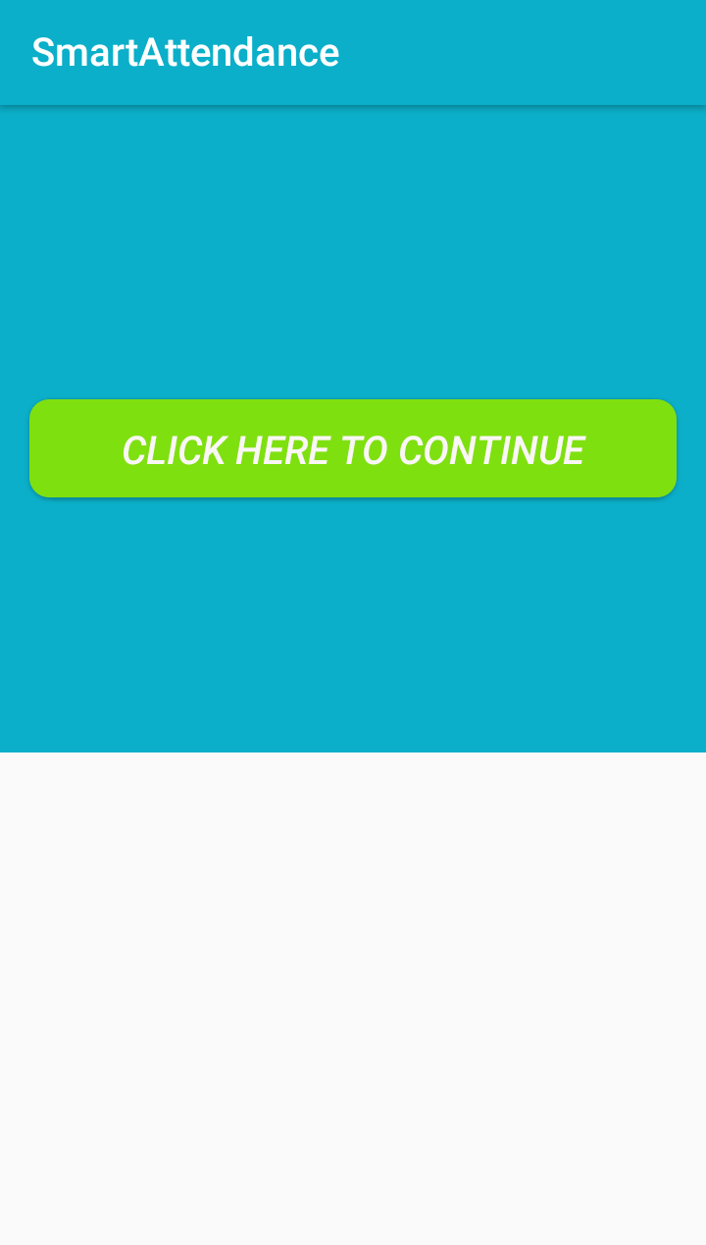

after clicking on that button it will navigate to another screen/activity it contains three buttons called "Student Report ","Student Data Upload", "Mark Attendance" and one Image View .

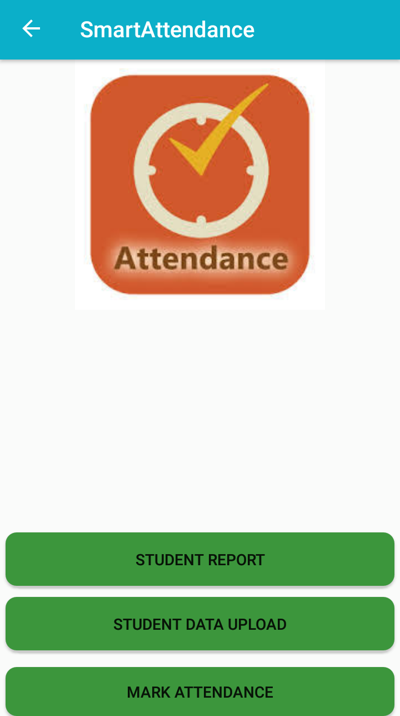

now,if we enter into Student Data Upload

1.STUDENT DATA UPLOAD

By clicking on the button 'student data upload' it will navigate to another screen called LOGIN it contain two EditText and one button.

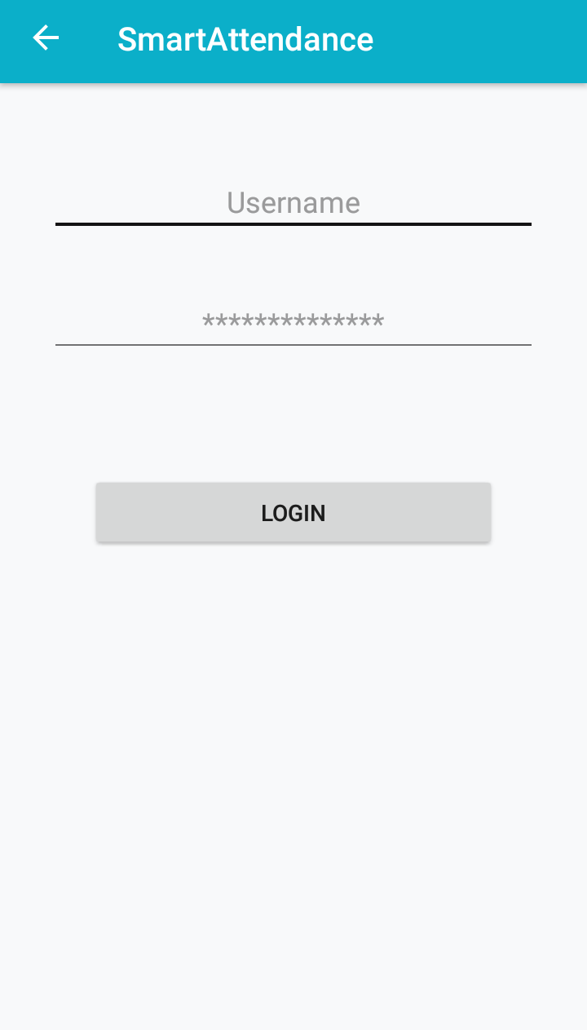

after filled the respective details and when we click on login button.this will navigate to another activity/screen .Here there will be four EditText and three Spinners and one Button.Here we will fill the students details and by clicking on the SUBMIT Button the student data will be saved and stored into firebase.

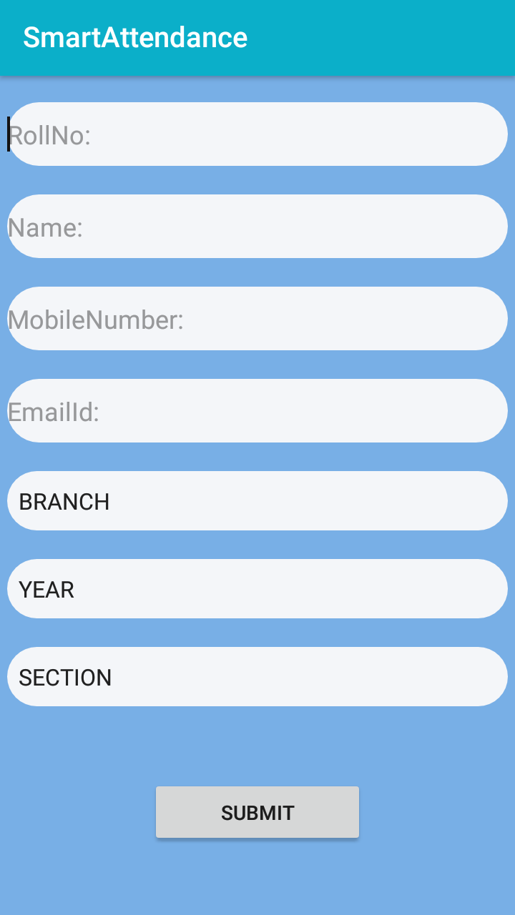

next , if we enter into Mark Attendances

2.MARK ATTENDANCE

By clicking on the button 'mark attendance' it will navigate to another screen called LOGIN it contain two EditText and one button.

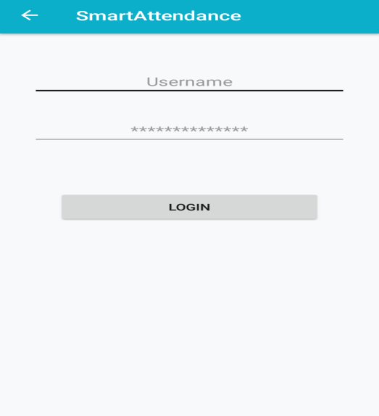

after filled the respective details and when we click on login button.this will navigate to another activity/screen there we can mark the attendance by filling the respective details branch,year,section and data by reference to those details respective student details will be displayed on the TextView by clicking on the GET button.the Toast message will displayed like attendance posted successfully when we can give attendance for the students by clicking on the box which are infront of student details.

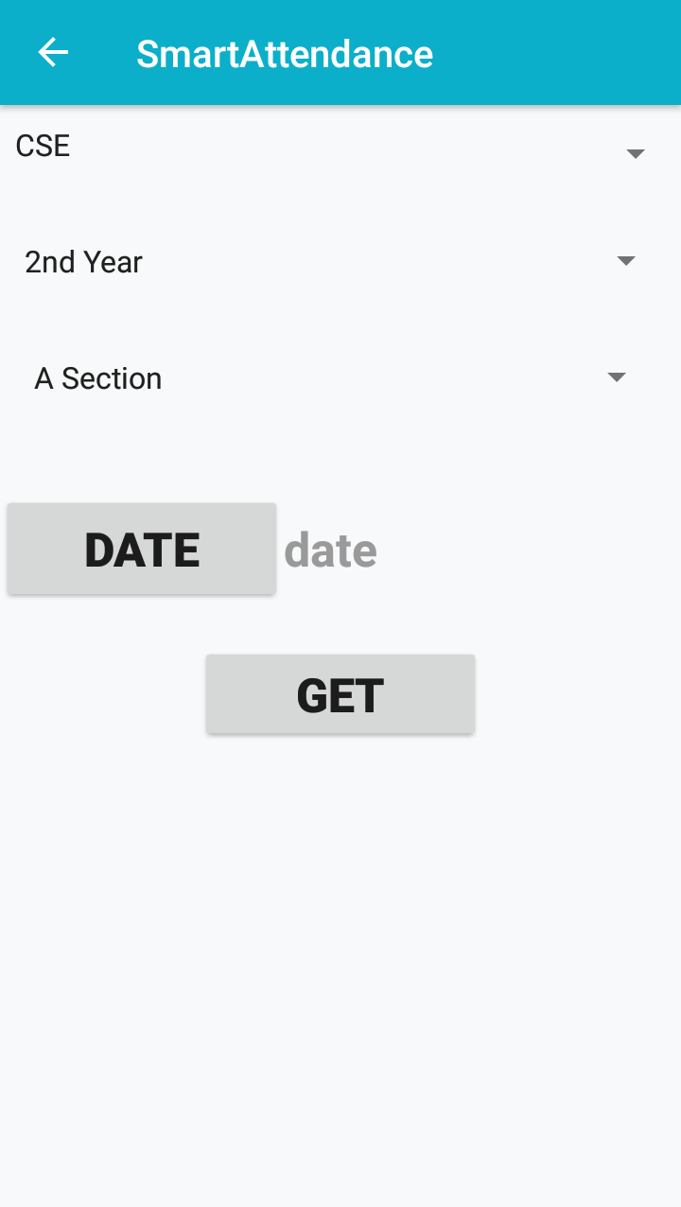 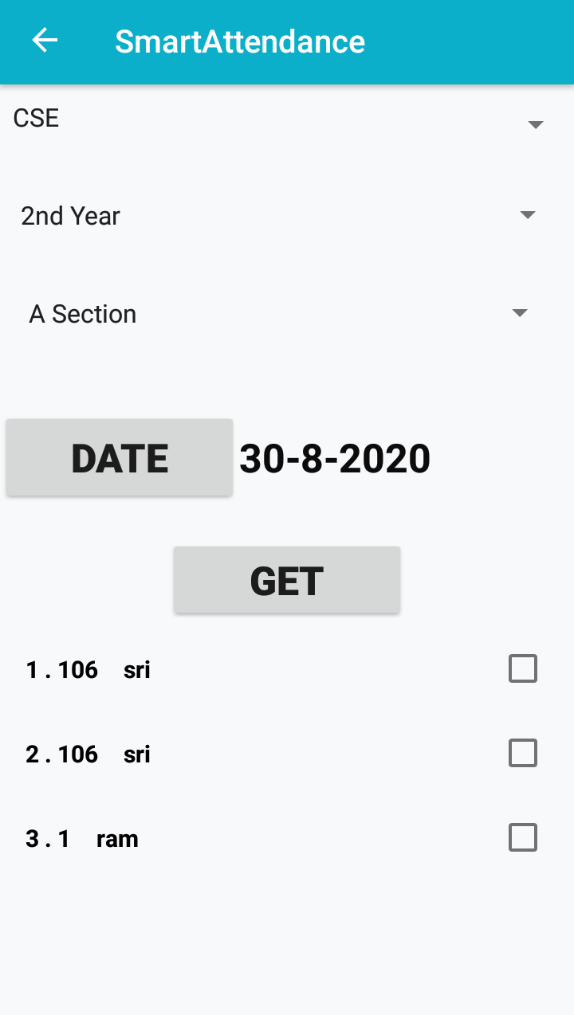

next,if we enter into student report

3.STUDENT REPORT

This will contains two EditText ,four Spinner,one TextView and one Button. after filling the respective details and when we click on the GET REPORT Button the report will generate .report contain no of working days and attendance of the students (present/absent).

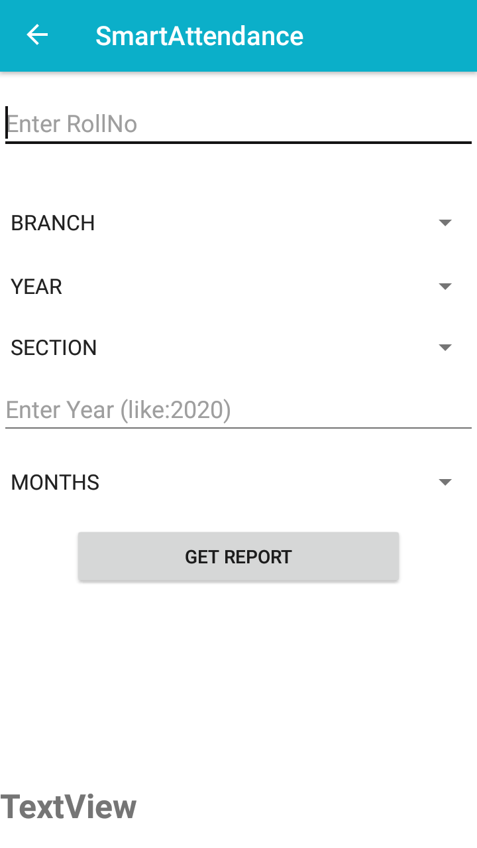

this is an easy way for posting adding students and posting the attendance to the students.